Practical 1: HTML program to create resume preparation using tables.
<!DOCTYPE html>
<html lang="en">

<head>
<meta charset="UTF-8" />
<meta name="viewport" content="width=device-width, initial-scale=1.0" />
<title>Pratical 1: Resume</title>
<style>
table {
width: 100%;
border-collapse: collapse;
margin-bottom: 20px;
}

th,
td {
border: 1px solid #dddddd;
text-align: left;
padding: 8px;
}

th {
background-color: #f2f2f2;
}
</style>
</head>

<body>
<h1>Vedanand Jha</h1>
<p>
Email: vnjha0@gmail.com | Phone: 8004611106 | LinkedIn: www.linkedin.com/in/vedanand-jha-291893259
</p>

<h2>Education</h2>
<table>
<tr>
<th>Degree</th>
<th>Institution</th>
<th>Year</th>
<th>Percentage</th>
</tr>
<tr>
<td>Bachelor of Technology in Computer Science</td>
<td>University of Lucknow</td>
<td>2026</td>
<td>Current</td>
</tr>
<tr>
<td>Intermediate</td>
<td>Oxford Public School</td>
<td>2021</td>
<td>81%</td>
</tr>
<tr>
<td>High School</td>
<td>Saraswati Shishu Mandir Senior Secondary School</td>
<td>2019</td>
<td>95%</td>
</tr>
</table>

<h2>Work Experience</h2>
<table>
<tr>
<th>Position</th>
<th>Company</th>
<th>Year</th>
</tr>
<tr>
<td>Student coordinator in communication team</td>
<td>TPC Lucknow University</td>
<td>2023-2024</td>
</tr>
</table>

<h2>Skills</h2>
<p>Programming Languages: C, Java</p>
<p>Web Technologies: HTML, CSS</p>
<p>Database: SQL</p>
</body>

</html>

Output:
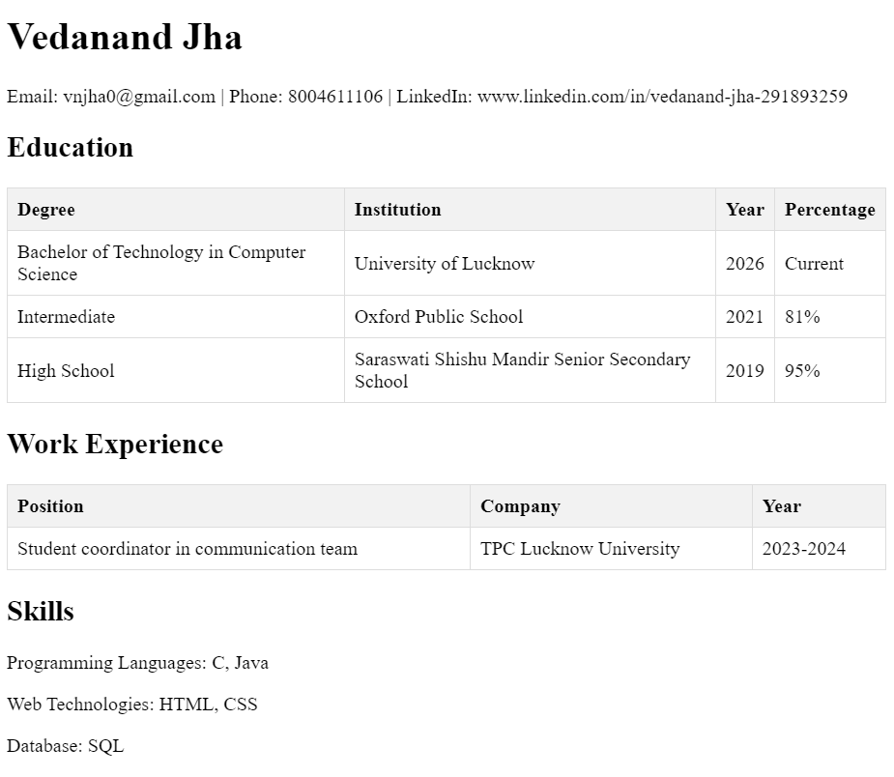
Practical 2: HTML program for home page creation using frames.
<!-- main.html -->
<html>

<head>
<meta charset="UTF-8">
<meta name="viewport" content="width=device-width, initial-scale=1.0">
<title>Home Page with Frames</title>
</head>
<frameset rows="20%, 80%" frameborder="0">
<frame src="2a.html" name="header" scrolling="no">
<frameset cols="20%, 80%" frameborder="0">
< <frame src="2b.html" name="sidebar" scrolling="auto">
<frame src="2c.html" name="main" scrolling="auto">
</frameset>
</frameset>

</html>

<!-- 2a.html -->
<html>

<head>
<meta name="viewport" content="width=device-width, initial-scale=1.0" />
</head>

<body>
<h1>Vedanand Jha</h1>
<h2> Objective </h2>
<p>Looking to use my computer science skills to help create new ideas and solutions in research and development.</p>
</body>

</html>

<!-- 2b.html -->

<html>

<head>
<meta name="viewport" content="width=device-width, initial-scale=1.0" />
</head>
<h2>Contact Me: </h2>
<p>

<body>
Email: vnjha0@gmail.com <br>
Phone: 8004611106<br>
Linkedin: <a href="https://www.linkedin.com/in/vedanand-jha-291893259/">vedanand-jha-291893259</a>
</p>
<hr>
<h2>Skills</h2>
<p>Programming Language: C, Java</p>
<p>Database: SQL</p>
<p>Web Technologies: HTML, CSS</p>
</body>

</html>

<!-- 2c.html -->
<html>

<head>
<meta name="viewport" content="width=device-width, initial-scale=1.0" />
</head>

<body>
<h2>Education</h2>
<table>
<tr>
<th>Degree</th>
<th>Institution</th>
<th>Year</th>
<th>Percentage</th>
</tr>
<tr>
<td>Bachelor of Technology in Computer Science</td>
<td>University of Lucknow</td>
<td>2026</td>
<td>Current</td>
</tr>
<tr>
<td>Intermediate</td>
<td>Oxford Public School</td>
<td>2021</td>
<td>81%</td>
</tr>
<tr>
<td>High School</td>
<td>Saraswati Shishu Mandir Senior Secondary School</td>
<td>2019</td>
<td>95%</td>
</tr>
</table>
<h2>Work Experience</h2>
<table>
<tr>
<th>Position</th>
<th>Company</th>
<th>Year</th>
</tr>
<tr>
<td>Student coordinator in communication team</td>
<td>TPC Lucknow University</td>
<td>2023-2024</td>
</tr>
</table>
</body>

</html>

Output:
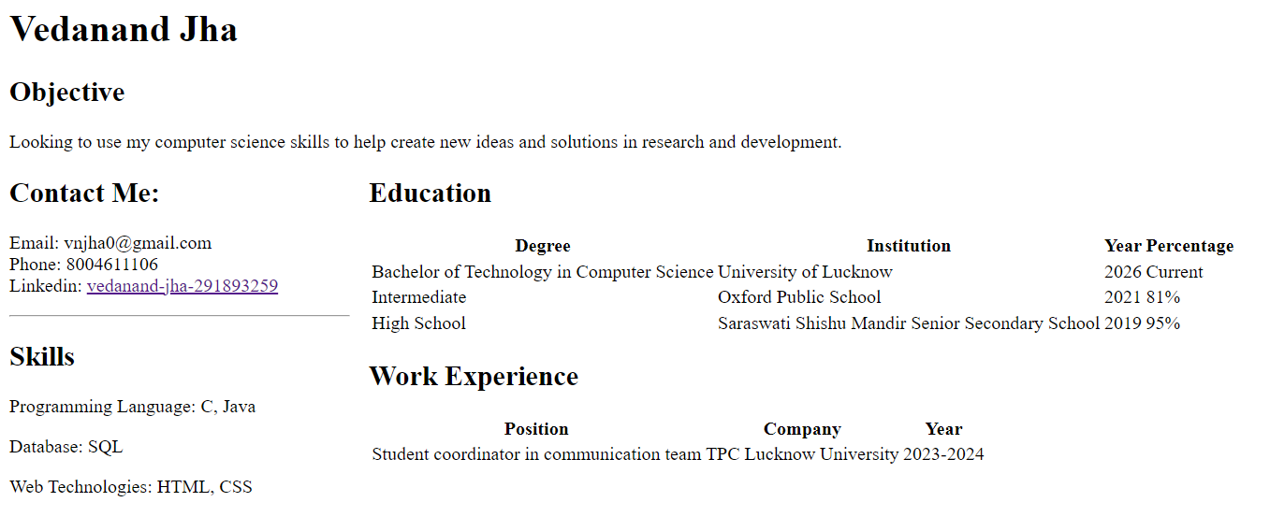

Practical 3: HTML program for form creation.
<!DOCTYPE html>
<html lang="en">

<head>
<meta charset="UTF-8">
<meta name="viewport" content="width=device-width, initial-scale=1.0">
<title>Practical 3: Contact Form</title>
<style>
form {max-width: 400px;
margin: 0 auto;
}

label, input, textarea {
display: block;
margin-bottom: 10px;
}
</style>
</head>

<body>
<center>

<h1>Contact Us</h1>

<form action="/submit-form" method="post">

<label for="name">Name:</label>

<input type="text" id="name" name="name" required>

<label for="email">Email:</label>

<input type="email" id="email" name="email" required>

<label for="message">Message:</label>

<textarea id="message" name="message" rows="4" required></textarea>

<input type="submit" value="Submit">

</form>

</center>
</body>

</html>
Output:
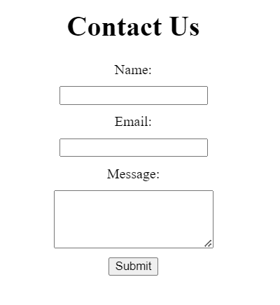

Program 4: Create a web page to embed an image map in a web page using HTML
<!DOCTYPE html>

<html>

<head>

<meta name="viewport" content="width=device-width, initial-scale=1.0">

<title>Practical 4: Image Map</title>

<style>
img{
border: 2px solid black;
}
</style>

</head>

<body>

<h1>Clickable Image Map Example</h1>

<img src="image.jpg" alt="Image Map Example" usemap="#imagemap">

<map name="imagemap">

<area shape="rect" coords="0,0,50,50" href="section1.html" alt="Section 1">
<area shape="rect" coords="50,0,100,50" href="section2.html" alt="Section 2">

<area shape="rect" coords="0,50,50,100" href="section3.html" alt="Section 3">

<area shape="rect" coords="50,50,100,100" href="section4.html" alt="Section 4">

</map>

</body>

</html>

Output:

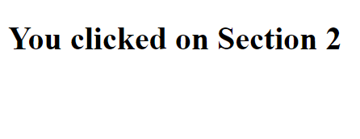
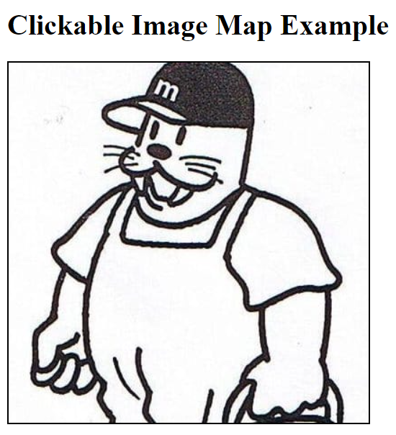

Practical 5: Create a web page to fix the hot spots and to show all the related information when the hot spots are clicked using HTML.
<html>
<head>
<title>Practical 5: Clickable Image Map with Information</title>
<script>
function computer() { alert("You clicked the computer!");} function coffee() { alert("You clicked the coffee!");}
</script>
</head>
<body>
<center>
<h1>Clickable Image Map with Information</h1>
<p>Click on the computer, the phone, or the cup of coffee to get a simple alert:</p>
<img src="Testing image.jpg" alt="Workplace" usemap="#workmap" width="400" height="379">
<map name="workmap">
<area shape="rect" coords="34,44,270,350" alt="Computer" onclick="computer()">
<area shape="circle" coords="337,300,44" alt="Cup of coffee" onclick="coffee()">
</map>
</center>
</body>
</html>

Output:
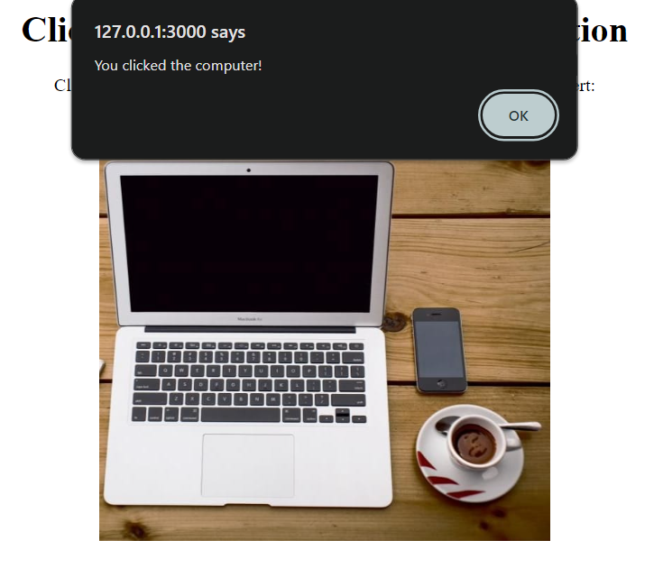

Practical 6: Create a web page to get the coordinates from an image using java script.
<!DOCTYPE html>

<html lang="en">

<head>

<meta charset="UTF-8">

<meta name="viewport" content="width=device-width, initial-scale=1.0">

<title>Practical 6: Get Image Coordinates</title>

<style>
#image-container {

position: relative;

}

#info-container {

max-width: 400px;

margin: 20px;
padding: 10px;

background-color: #f0f0f0;

border: 1px solid #ccc;
</style>

</head>

<body>

<h1>Get Image Coordinates</h1>

<div id="image-container">

<img id="clickable-image" src="image.jpg" alt="Clickable

Image">

</div>

<div id="info-container">

<h2>Click Information</h2>
<p id="coordinates"></p>

</div>

<script>

var image = document.getElementById("clickable-image");

var infoContainer = document.getElementById("info-container");

var coordinatesText = document.getElementById("coordinates");

image.addEventListener("click", function (event) {

var offsetX = event.offsetX; var offsetY = event.offsetY;

coordinatesText.textContent = "Coordinates:(" + offsetX + "," + offsetY + ")";

infoContainer.style.display = "block";

});

</script>
</body>
</html>

Output:
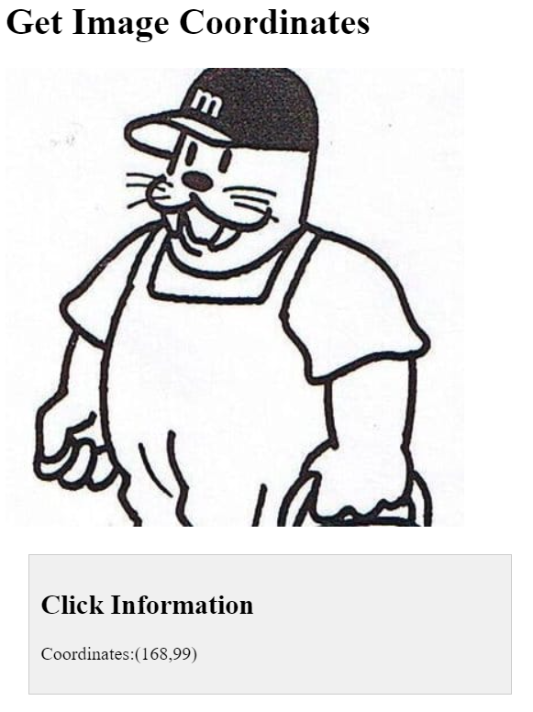

Practical 7: Create a web page with all types of cascading style sheets.
<!DOCTYPE html>

<html lang="en">

<head>

<meta charset="UTF-8">

<meta name="viewport" content="width=device-width, initial-scale=1.0">

<title>Practical 7: CSS Types</title>

<link rel="stylesheet" href="style.css">

<style>
body {

font-family: Arial, sans-serif;
background-color: #f0f0f0;
color: #333;
}

h1 {

color: #007bff;
}

p {
font-size: 16px;
}

#inline-styled {

border: 2px solid #28a745;
padding: 10px;
margin-top: 10px;
font-weight: bold;
color: #28a745;
}
</style>

</head>

<body>

<h1>Types of CSS</h1>

<p style="color: rgb(7, 139, 38); font-size: 20px; font-weight: bold;">This is a paragraph styled with internal
styles.</p>

<div id="inline-styled">

This is a div with inline styles.

</div>

<div id="external-styled">

This is a div with external styles.

</div>
</body>
</html>

<!-- styles.css
#external-styled {
background-color: #ffc107;
padding: 10px;
margin-top: 10px;
font-weight: bold;
color: #333;
} -->

Output:
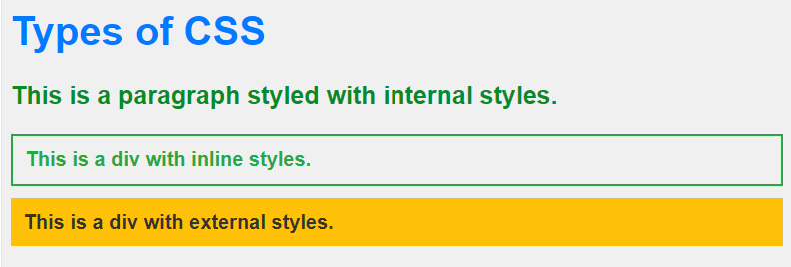

Practical 8: Design HTML form for keeping student record and validate it using Java script.
<!DOCTYPE html>

<html lang="en">

<head>

<meta charset="UTF-8">

<meta name="viewport" content="width=device-width, initial-scale=1.0">

<title>Practical 8: Student Record Form</title>

<style>
body {

font-family: Arial, sans-serif;
max-width: 400px;
margin: 20px auto;
}

label {

display: block;
margin-bottom: 5px;
}

input {

width: 100%;
padding: 8px;
margin-bottom: 10px;
}

button {

background-color: #4caf50;

color: white;

padding: 10px;
border: none;
cursor: pointer;

}
</style>

</head>

<body>

<h2>Student Record Form</h2>

<form id="studentForm" onsubmit="return validateForm()">

<label for="name">Name:</label>

<input type="text" id="name" name="name" required>

<label for="email">Email:</label>

<input type="email" id="email" name="email" required>

<label for="age">Age:</label>

<input type="number" id="age" name="age" required>

<button type="submit">Submit</button>
</form>

<script>

function validateForm() {

var name = document.getElementById("name").value;

var email = document.getElementById("email").value;

var age = document.getElementById("age").value;

if (name === "" || email === "" || age === "") {

alert("All fields must be filled out");

return false;

}

if (isNaN(age) || age < 0) {

alert("Please enter a valid age");

return false;

} return true;
}

</script>

</body>

</html>

Output:

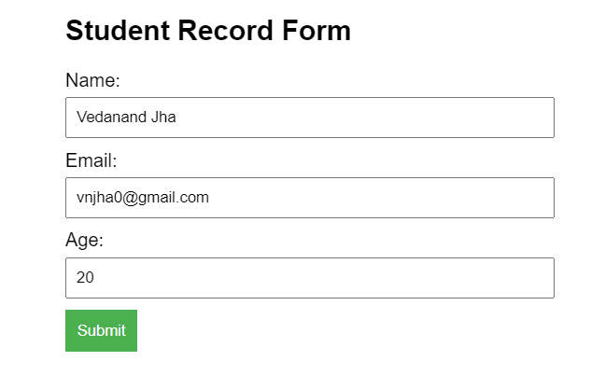

Practical 9: Writing program in XML for creation of DTD, which specifies set of rules.
student_records.xml
<!DOCTYPE student_records SYSTEM "student_records.dtd">

<student_records>

<student>
<name>Alex Johnson</name>
<email>alex.johnson92@example.com</email>
<age>23</age>
<course>Computer Science</course>
</student>

<student>
<name>Emily Roberts</name>
<email>emily.roberts88@example.com</email>
<age>21</age>
<course>Biotechnology</course>
</student>
</student_records>

student_records.dtd
<!ELEMENT student_records (student+)>
<!ELEMENT student (name, email, age, course)>
<!ELEMENT name (#PCDATA)>
<!ELEMENT email (#PCDATA)>
<!ELEMENT age (#PCDATA)>
<!ELEMENT course (#PCDATA)>

Output:
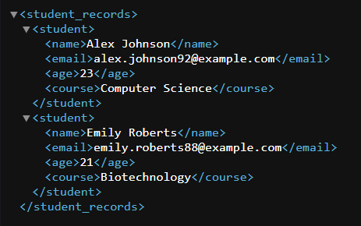

Practical 10: Create a style sheet in CSS/XSL & display the document in internet explorer.
Book.xml
<?xml version="1.0" encoding="UTF-8"?>
<?xml-stylesheet type="text/css" href="Rule.css"?>
<books>
<heading>Welcome to the Library </heading>
<book>
<title>Title : Web Programming</title>
<author>Author: Chrisbates</author>
<publisher>Publisher: Wiley</publisher>
</book>

<book>
<title>Title: Internet world-wide-web</title>
<author>Author: Ditel</author>
<publisher>Publisher: Pearson</publisher>
</book>

<book>
<title>Title: Computer Networks</title>
<author>Author: Foruouzan</author>
<publisher>Publisher: Mc Graw Hill</publisher>
</book>
</books>

Rule.css
books {
color: rgb(0, 0, 0); background-color: rgb(255, 255, 255); width: 100%; }
heading {
color: green; background-color: powderblue; font-size: 40px; }
heading, title, author, publisher {
display: block; margin-left: 5vw; text-align: center; }
title, author, publisher {
font-size: 20px;}

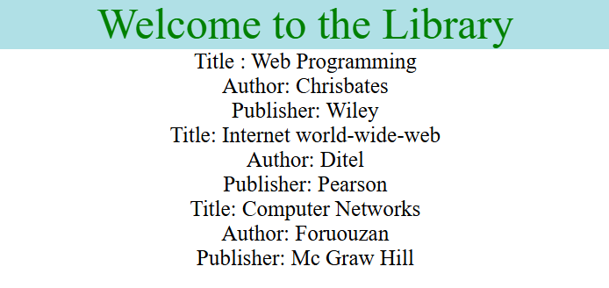
Output:

